The Template spreadsheets are locked & password protected to prevent unauthorized changes and access to sections that are not data entry fields.

1. Lookup Values sheet/tab is hidden to prevent accidental changes to the lookup values.
   * Process to hide the Lookup Values sheet/tab:
     1. Select the Lookup Values sheet/tab.
     2. Select the **Home** menu/ribbon option and then click **Format**.
     3. On the **Format** menu drop-down click on **Hide/Unhide** and then on **Hide Sheet**.
     4. The Lookup Values sheet/tab should now be hidden and not visible.
   * Process to unhide the Lookup Values sheet/tab:
     1. Select the Home menu/ribbon option and then click Format.
     2. On the Format menu drop-down click on Hide/Unhide and then on Unhide Sheet… .
     3. Select the Lookup Values sheet/tab in the list and then click OK. The Lookup Values sheet/tab should now be visible.
2. The individual spreadsheets are completely locked and non-editable, except for those cells that users are supposed to enter data into.
   * Password to protect/unprotect worksheets: gttstemplateversion3
   * Process to protect a worksheet:
3. Select all the cells that should be unprotected. Use CTRL-CLICK as needed.
4. RIGHT-CLICK & select Format Cells…
5. On the Protection tab, remove the checkmark from the Locked checkbox and click OK.
6. Select the Review menu/ribbon option and then click Protect Sheet.
7. Enter the password (gttstemplateversion3) and set the checkboxes as shown:

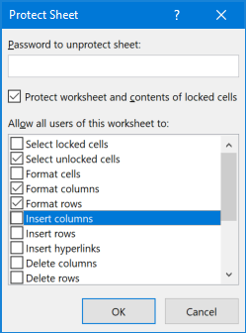

* Reference URL on how to protect/unprotect specific cells: <https://www.laptopmag.com/articles/lock-cells-excel>

1. Once all the individual sheets have been locked down, the entire workbook .xlsx file needs to be protected against structure changes.
   * Password to protect/unprotect the entire workbook (.xlsx file): gttstemplateversion3
   * Process to protect the workbook (.xlsx file):
     1. Select the **Review** menu/ribbon option and then click **Protect Workbook**.
     2. Enter the password (gttstemplateversion3) and set the checkboxes as shown:

